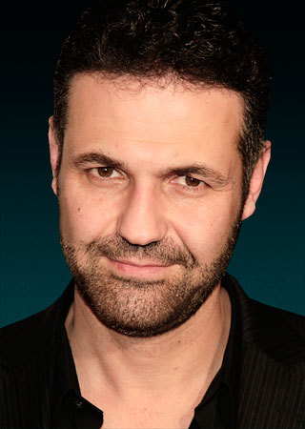
Khaled Hosseini
(Born March 4, 1965) is a novelist and physician from Afghanistan. He is currently living in the United States, where he is a citizen. His 2003 debut novel, The Kite Runner, was an international bestseller, selling more than 10 million copies worldwide. His second, A Thousand Splendid Suns, was released on May 22, 2007. In 2008, the book was the bestselling novel in the UK (as of April 11, 2008), with more than 700,000 copies sold.

Biography
Hosseini was born in Kabul where his father worked for the Afghanistan Foreign Ministry. In 1970, Hosseini and his family moved to Tehran, Iran, where his father worked for the Embassy of Afghanistan. In 1973, Hosseini's family returned to Kabul, and Hosseini's youngest brother was born in July of that year.
In 1976, Hosseini's father obtained a job in Paris, France and moved the family there. They chose not to return to Afghanistan because PDPA (People’s Democratic Party of Afghanistan) had seized power through a bloody coup in April 1978. Instead, in 1980 they sought political asylum in the United States and made their residence in San Jose, California.
Hosseini graduated from Independence High School in San Jose in 1984 and enrolled at Santa Clara University, where he earned a bachelor's degree in biology in 1988. The following year, he entered the University of California, San Diego, School of Medicine, where he earned his M.D. in 1993. He completed his residency in internal medicine at Cedars-Sinai Medical Center in Los Angeles in 1996. He practiced medicine until a year and a half after the release of The Kite Runner.
Hosseini is currently a Goodwill Envoy for the United Nations High Commissioner for Refugees (UNHCR). He lives in Northern California with his wife, Roya, and their two children.

Influences
When Khaled Hosseini was a child, he read a great deal of Persian poetry as well as Persian translations of novels ranging from Alice in Wonderland to Mickey Spillane's Mike Hammer series. Hosseini's memories of peaceful pre-Soviet era Afghanistan, "I have very fond memories of my childhood in Afghanistan" as well as his personal experiences with Afghanistan's Hazara people, led to the writing of his first novel, The Kite Runner. One Hazara man, named Hossein Khan, worked for the Hosseinis when they were living in Iran. When Khaled Hosseini was in third grade, he taught Khan to read and write. Although his relationship with Hossein Khan was brief and rather formal, Hosseini's fond memories of this relationship served as an inspiration for the relationship between Hassan and Amir in The Kite Runner.

Novels
- The Kite Runner is the story of a young boy, Amir, juggling to establish a closer rapport with his father and coping with memories of a haunting childhood event. The novel is set in Afghanistan, from the fall of the monarchy until the collapse of the Taliban regime, and in the San Francisco Bay Area, specifically in Fremont, California. Its many themes include ethnic tensions between the Hazara and the Pashtun in Afghanistan, and the immigrant experiences of Amir and his father in the United States. The novel was the number three best seller for 2005 in the United States, according to Nielsen BookScan. The Kite Runner was also produced as an audiobook read by the author. The Kite Runner has been adapted into a film of the same name released in December, 2007.
- Hosseini's second novel, A Thousand Splendid Suns, the story of two women of Afghanistan, Mariam and Laila, whose lives become entwined, was released by Riverhead Books on May 22, 2007, simultaneous with the Simon & Schuster audiobook. Movie rights have been acquired by producer Scott Rudin and Columbia Pictures.

